Sensors performance evaluation and monitoring using Apple smart watches

*Note: Sub-titles are not captured in Xplore and should not be used

line 1: 1st Given Name Surname   
line 2: *dept. name of organization   
(of Affiliation)*  
line 3: *name of organization   
(of Affiliation)*line 4: City, Country  
line 5: email address or ORCID

line 1: 4th Given Name Surname  
line 2: *dept. name of organization*  
*(of Affiliation)*  
line 3: *name of organization   
(of Affiliation)*line 4: City, Country  
line 5: email address or ORCIDline 1: 2nd Given Name Surname  
line 2: *dept. name of organization   
(of Affiliation)*  
line 3: *name of organization   
(of Affiliation)*line 4: City, Country  
line 5: email address or ORCID

line 1: 5th Given Name Surname  
line 2: *dept. name of organization   
(of Affiliation)*  
line 3: *name of organization   
(of Affiliation)*line 4: City, Country  
line 5: email address or ORCIDline 1: 3rd Given Name Surname  
line 2: *dept. name of organization   
(of Affiliation)*  
line 3: *name of organization   
(of Affiliation)*line 4: City, Country  
line 5: email address or ORCID

line 1: 6th Given Name Surname  
line 2: *dept. name of organization   
(of Affiliation)*  
line 3: *name of organization   
(of Affiliation)*line 4: City, Country  
line 5: email address or ORCID

*Abstract*— This paper studies the changes on Apple Watch sensor readings from one generation to another in order to determine their reliability. These tests are conducted using a native Swift application and the frameworks provided by Apple which are likely to be used in a variety of monitoring applications available in the App Store. We want to determine if the devices’ price increase translates in better readings or if the cheaper versions are just as good.

Keywords—Apple Watch, Swift, Heart Rate BPM, GPS, Pedometer

# Introduction (*Heading 1*)

These days, wearable devices are nothing unusual, with fitness trackers and smartwatches becoming more affordable and more powerful. The sensor readings in these devices are becoming more accurate, bringing software developers a lot of possibilities to create new health related applications. The majority of sensors available in wearable devices are: heart rate sensor, pedometer, accelerometer, gyroscope, GPS and a few even have an ECG one. They also make use of data connectivity for communication: Wi-Fi, Bluetooth, some of them Cellular (e.g., LTE).

Most smartwatches use complex operating systems: Samsung uses Tizen, Google created an Android-based OS called wearOS, Apple created the iOS-based watchOS. Each of these provide complex IDEs, allowing developers to write applications that run natively: Tizen has Tizen Studio (C language), wearOS has Android Studio (Java or Kotlin), watchOS has Xcode (Objective-C or Swift). Also, there are possibilities for hybrid applications, written in general-purpose languages (C# / Xamarin, included in the .NET framework).

One of the most popular commercial wearable devices is the Apple Watch. Alongside the basic sensors, the various generations come with competent processors and more than enough memory upon which the software runs on. The operating system is currently at its seventh iteration (watchOS 7) and since watchOS 6, it can run standalone applications, called by Apple as Independent Apps (https://developer.apple.com/documentation/watchkit/creating_independent_watchos_apps). Until that point, applications required an iPhone app that had an Apple Watch component, meaning that the app could not be installed without its iOS counterpart. That changed and now the Apple Watch has its own App Store, so applications can be installed and run using only the Apple Watch.

Introducing Independent Apps meant that the future of wearable devices does not depend on the future of the smartphones anymore. As the hardware gets more powerful, the applications get more complex. Today, software engineers have the ability to write software made with a smartwatch-first approach. We can create applications that take full advantage of the sensors available in such a device. One of the questions that comes to mind is: how reliable are the sensor readings on various generations of the same platform, in this case various generations of the Apple Watch?

# State of the art – luat din licenta

## Health Monitoring Systems

As [1] states, using smart devices as health monitoring systems that can monitor an individual’s health parameters, such as heart rate, temperature or blood pressure, can lead to a real advancement in an individual’s quality of life and in healthcare services.

By providing such a system with personal data, software algorithms can assist and advise people regarding possible health issues. More than that, patients suffering from chronic diseases can live a more independent life while medical doctors can still monitor their conditions. Telemedicine has been around for a while now and smart devices are improving that, especially in poorly developed countries, as well as in crisis situations.

One of the big challenges of healthcare services is represented by patient prioritization. With real-time data gathered from monitoring systems, this process can be optimized which ultimately leads to saving more lives.

This is possible due to the advancements in the Internet of Things. As [2] concludes, such systems cannot exist without HTTPS web servers and web services, e.g. RESTful. The connection between the sensors and a main device is done over a Low-Power Wireless Network (LPWN) such as IEE 802.15.4 (ZigBee) or IEE 802.15.1 (Bluetooth). The main device must connect to the internet, ideally through a wireless network using Wi-Fi or a cellular network.

[3] exemplifies a real-time monitoring system, motivating that telemedicine has already been adopted for patients with chronic diseases, such as asthma, diabetes, or heart failures because these conditions require long-term, continuous monitoring in order to minimize the threat. More than that, the patients can often be located far away from medical facilities and going to the doctor on a regular basis is something that takes time and can have a financial impact. This paper presents a system where various sensors, e.g. heart rate sensors, are connected to an Android smartphone over a Bluetooth Low Energy (BLE) connection. An application for the smartphone is created in Android Studio which receives the data, adds GPS data using the built-in sensor of the device and sends it to a PHP web application that provides a REST API and stores the data received on a SQL database and allows authorized doctors to view patients’ data. This system also presents a fuzzy logic approach to interpret data from a heart rate sensor, a blood pressure sensor and a body temperature sensor in order to automatically warn the user about possible diseases: hypothermia, bradycardia, tachycardia, hypotension/hypertension or just a simple fever. This system has been tested on 40 cardiac patients and found that, depending on the area and the networks, the delays can be up to 6 minutes which is acceptable, but certainly can be improved. Also, this system generated false alarms.

## Monitoring during a pandemic

According to [4], monitoring of people exposed to confirmed cases of patients suffering of COVID-19 in the United States is done by daily telephone or text with the medical personnel about fever or other symptoms. This is not an efficient way. People are asked to check their own body temperature regularly and report back to the medic. This monitoring technique is inefficient in so many ways because it relies on individuals’ behavior and takes medics’ precious time in such hard times. As of March 2020, the United States do not make use of any automated health monitoring system to fight the pandemic. This is even more important when talking about more difficult situations, such as pregnancy, as [5] recommends future mothers to regularly check their heart rate, body temperature and blood pressure. Symptoms spotted early can prevent complications and doctors can decide a premature delivery. Also, the study shows that the virus does not transmit to the fetus in late stages of the pregnancy, but the mother must be prepared for a temporary separation from the baby, so doctors can suggest psychological consultations. Real-time health monitoring systems can spot symptoms early in the development of the disease and can help everyone, from patients to medical staff, to act properly.

## Wearable devices

As [6] stated in 1999, researchers always focused on making the components of a computer smaller, allowing its user to carry it around. The authors defined the relationship between a human and the computer sitting on a desk as a weak one. Humans can often feel in an adversarial relationship to the desktop PC and, in a similar way, the computer alone does not know much about the user either. Even portable devices such as laptops and smartphones, which since then have replaced the personal digital assistants, still have a gap between the computer and its user. This paper predicted that wearable devices would create a symbiosis relationship between them and the human, using the data gathered from a daily worn computer to improve an individual’s life.

Fast-forwarding to 2015, we start seeing news reports, for example [7], where the Apple Watch, a commercially available wearable computer, starts saving lives of its users based on heart rate sensor readings. These readings can detect symptoms of cardiovascular diseases. In this case, the person had a resting heart rate of 145 beats per minute which is a symptom of rhabdomyolysis, a condition that causes severe muscle pain and weakness [8]. When the smartwatch detected that, it suggested the user a visit to a doctor. That visit turned out to be lifesaving.

Besides the critical situations that can be prevented with the help of this kind of technology, other benefits should, nevertheless, be considered. [9] introduces the “quantified self” term, where a wearable device that gathers information about physical activity can motivate and educate an individual to gain better health and making better habits. With more and more jobs leading to a sedimentary lifestyle, such widely available devices can improve population health. This is done by setting goals and sending reminders. For example, as the World Health Organization advises, smartwatches usually set a goal of 30 minutes exercise per day. While they do not give a specific definition of exercise, this can usually be anything that involves effort, from a fast-paced walk to a real workout. The watch uses sensors and algorithms to determine that. As the day goes by, it gives different notifications to the user if the goal is not met, with motivating messages telling that there is still time to be on track with a healthy lifestyle. This is the feedback loop in which the user is constantly motivated. Another part of this loop is the reward, a virtual medal given by the smartwatch. The rewards are used to motivate the user, but their functionality is quite different than one would expect. They are based on anticipated regret, someone’s fear of not winning something.

Unfortunately, the same paper as before concludes that the current feedback loop is not enough to get everyone on board with this technology, as hardware manufacturers and software developers need to improve their engagement strategies. The authors back this statement up by numbers, exemplifying a survey conducted on 6223 people. It concluded that more than half of the people who have bought a wearable device have stopped using them after a while.

# A review on sensors

## Heart rate sensors in wearable devices

According to [10] , the majority of heart rate sensors in today’s fitness trackers or smartwatches use a cost effective and non-invasive measurement method called photoplethysmography (PPG).

An example of a PPG algorithm is explained in detail in [11]. Basically, this method uses 2 green LEDs as light sources and a photodetector in the immediate proximity of the skin (on the user’s wrist) in order to quantify the volumetric alternations in blood flow. The data received by the photodetector goes through an analog to digital converter (ADC) to the microcontroller. The signal obtained can be seen in Figure 2.1, with each heartbeat given by each Gaussian distribution. A low pass filter is used to filter out the noise.

|  |
| --- |
| https://lh3.googleusercontent.com/uxN-pT80gU8qpr-7ow3CXK0hGxspaM0-AMV9WWMmPQf28QIFPPEQo00rwtCeRChwxjXKBmGi2azsac9-GIlgRnTAxFQYKBWAv3iHmplvpZDdn2BENgiarMrhcqt3CLR_2o9IdF0H |
| Figure 2.1 Obtained discrete signal obtained from a PPG sensor [11] |

The color of the LEDs is important because, according to [12], colors of longer wavelengths have a deeper skin tissue penetration, but as we go to higher wavelengths (such as an infrared light), we encounter more motion artifacts.

As explained in [13], motion artifacts appear due to discontinuous contact of the skin and the sensor. This is a serious problem when talking about wearable devices, with every move of a person’s hand slightly moving the device as well. This is even a bigger problem when tracking information during a heavy workout or jogging. This paper presents an algorithm that uses an accelerometer data to cancel errors due to motion. The results have a high accuracy with an error of 2.57% at a maximum speed of 17km/h, with an order of complexity O (N logN) per second and 10Hz sampling rate. It also concludes that green LEDs give the best results. PPG motion efficiency is still a major research topic.

Going back to [10], the paper states that heart rate activity has turned out to be one of the most important heart parameters, a device of measuring it being much more accessible to an individual than a device to measure the Electrocardiogram (ECG) which requires electrodes in specific body locations, even though that is subject to change and will be explained in Chapter 2.3.4. Using the PPG method, heart rate variations (HRV) can be defined as the peak-to-peak interval. Different HRV values could also be symptoms of various diseases (e.g. cancer). Also, using the second derivative of the PPG signal we get the acceleration photoplethysmogram (APG), the acceleration indicator of the blood. APG is also used in the detection and diagnosis of cardiac abnormalities.

[14] proves that the Apple Watch has a maximum error of 10% when moving, making it just a little bit less accurate than a specialized chest strap that uses ECG signals.

## Step counter

Nowadays, a lot of devices come with specialized step counter chips (pedometers) and accelerometers, and the results of each implementation can vary. For example, the authors of [15] built a smartwatch app for the Samsung Galaxy Gear 2 that counts steps based on the raw accelerometer data available on the watch. The result turned out to be better than the built-in application available on the smartwatch, which Samsung claims it uses a pedometer chip. The paper also concludes that the built-in application has a 20% to 30% error in counting steps. [16] which tested the reliability of various accelerometers and pedometers concludes that the Omron pedometer they have tested was more reliable then accelerometer step counters. [17] tests the accuracy of a specialized step counter, the Fitbit Zip, in order to determine if such a device can be used to monitor patients with cardiac disease. The Fitbit Zip was accurate enough only at obvious walking speeds, over 3.6 km/h, which was considered a good result.

[18] presents a study that compares the Apple Watch Series 1 to the Fitbit Charge HR and concludes that the Apple Watch provides a more accurate step counter. [19] is another study that validates the accuracy of the Apple Watch’s steps counter at various walking speeds, for adults with different body-mass indexes and age groups. According to Apple [20], the step counter is calibrated using GPS when the device is outdoors.

## Connectivity asta o putem scoate probabil

1.1.3Connectivity in wearable devices

Having to fit small cases, wearable devices have small batteries and all the connectivity solutions focus on small energy consumption and size.

1.1.3.1Wi-Fi

Modern smartwatches usually include the IEEE 802.11b/g/n with a frequency band of 2.4 GHz. While many question the decision of producers’ like Apple or Samsung to not include the novel 5 GHz band, [21] concludes that even the simplest applications can have a significant impact on power consumption at 5 GHz compared to a 2.4 GHz connection.

1.1.3.2Cellular

While there still exist wearable devices that use a usual Subscriber Identity Module (SIM) card, the modern wearable devices use an embedded SIM (eSIM), which, according to [22], is a chip on the device that allows the device owner to change the mobile network operator over the internet. That way, the eSIM chip can occupy much less space, being integrated into the SoC, allowing the manufacturer to optimize the hardware, while operators’ and consumers’ benefits remain the same.

1.1.3.3GPS

Most wearable devices use localization data. The ones that do not have a built-in GPS chip will use the paired phone’s sensors. But, according to [23], real-time monitoring of a route can discharge a smartwatch in a matter of hours, exemplifying on a Sony Smartwatch 3 that GPS tracking drew 3 times more battery than the display and CPU combined. In order to fix this, the article suggests a smaller sample rate and a path reconstruction algorithm that claims to reduce the battery consumption by 97% while having an error of only 7% related to the actual route.

1.1.3.4Bluetooth

For the short-range communications, most manufacturers choose to include the latest version of Bluetooth in their devices and that is Bluetooth 5.0. As explained in [24], this version focused on the low energy consumption, while still being faster and having a longer range than the previous one. Its main characteristics are a range of up to 200 meters, a data rate of up to 2 Mb/s and a latency lower than 3 milliseconds, all that while being in some cases even 2 times less power-consuming than Bluetooth 4.0.

1.1.4ECG

According to [25] the Apple Watch Series 4 was the first device to introduce an ECG sensor and receive clearance from the Food and Drug Administration (FDA) in the United States for atrial fibrillation (AF) detection. It has since been approved in the European Union as well.

A circuit is created between the watch back, where is a detector, and the watch crown which has built-in electrodes. This creates a single-lead electrocardiogram (iECG) which was as effective as the 12-lead ECG medical services use in detecting AF. Even so, having only one lead is still a limitation, as typical ECGs can diagnose more heart issues. *Figure 2.2* shows an ECG result from the Apple Watch.

|  |
| --- |
| https://lh4.googleusercontent.com/6iHB1sHspUSBz5ZE1_Mj_kc8FPsZYabCL3zm1KylHQugoBlfiUpqZD2j6-YQjrIS7_Qn8JED_O0No1JWevx8zR3t8aW3ta5fFBvYsc891ZptoXmGBiKTj7fC8e2TyPhQZQEBaMI0 |
| Figure 2.2 ECG on the Apple Watch [26] |

According to the official documentation [27], the watch can detect a sinusoidal rhythm (regular heart beat pattern) or atrial fibrillation (irregular heart beat pattern). While it cannot diagnose a disease, it can warn of its symptoms and advise visiting a doctor.

# Methodology

This research paper aims to check the reliability of sensors across different generations of a smartwatch. For that, we have chosen the Apple Watch Series 3, 4 and 5. We had them running the same application (native, written in Swift), thus seeing how different the sensors are from one generation to another. We think this is an important piece of information for consumers and developers as well because, at the time of writing, most generations can be found in stores, with Apple still selling the older Apple Watch Series 3 in its stores. We are trying to find out if consumers should save money by buying the older product, or if by paying more they actually get more health benefits alongside the new, shiny color and the brighter screen. Also, we want to find out if developers should fine-tune their application based on the generation of the product or if this tuning is done by the producer and the developers can rely on this platform.

Noticeable differences could mean that, as sensor technology available in commercial products improves, older generation products should be less or even not at all recommended to people who might ultimately depend on accurate sensor readings. Worse accuracy in GPS readings can become emergency services misleads. If the heart rate reading technology drastically improves over a year, older people should definitely buy the newer one, even if it costs them more. If pedometer data is not as accurate, the older generations shouldn’t be recommended to athletes. And maybe the most important, a developer for a health application should write, in a very noticeable way, the version of the watch upon which the application was tested on.

If the differences are insignificant, people should also know that paying more does not give them more accurate information about their health. For the majority of the world, buying a smartwatch can leave a mark on their bank account. Should someone who only wants this kind of device for their health benefits be worried that they do not have the latest version?

# Architecture and app structure

To test the sensor readings of multiple devices, we have created an Apple Watch app that gathers the data available on the smartwatches and either sends it to the iPhone app as a csv, from where it can be shared via email or any other sharing service. We’ve also created an API server using .NET Core with authentication and data posting functionalities for each user. This use case requires the authentication to be done by the phone app, as a text input method. The data is then stored in a SQLite database and can be viewed from a ReactJS web application. This architecture is presented in Figure x.

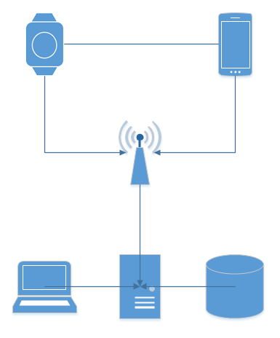

Figure x: Application architecture

The data we’re saving from the smartwatch sensor readings is: Heart Rate (beats per minute), GPS (latitude, longitude), Steps, Distance (meters). We’re also recording the time (HH:mm:ss) for each data sample.

The watch application is written in Swift and can run on any Apple Watch that runs on watchOS 6.1 or higher. The primarily used framework is WatchKit, which provides basic functionality: lifecycle methods (e.g. didAppear() - executes when an interface is initialized), labels, buttons.

To test our hypothesis, we are getting the data from the sensors the way Apple intended to and the way most of the developers will do it, by using the frameworks provided by Apple.

To allow continuous monitoring, the app first instantiates a workout session using an HKWorkoutSession object from the HealthKit framework. This way, the heart rate monitoring process can run in the background. An HKQuantityType object is instantiated, with the quantity type identifier set to heartRate. This object stores the most recent heart rate registered by the watch.

To get the GPS data, a CLLocationManager object from the CoreLocation framework is instantiated. Its desired accuracy property is set to kCLLocationAccuracyBest. Then, a continuously running function gets the latitude and longitude available on the watch’s readings.

To access the data from the built in pedometer, a CMPedometer object is instantiated from the CoreMotion framework. Then, a function starts the counting and the object gives the steps and distance in meters from when it started counting.

With the use of a Timer object, the app writes in a file, with comma separated values, all the data it has at a specific moment in time. Because of watchOS optimisations that we have no control over, the app may still be suspended for short periods of time, so in our testing we will wake the screen from time to time.

If the watch has an authentication token and an active internet connection, it can make POST requests to the API with the available data, at every second. If not, it can send the CSV file to the iPhone it is paired with, via Bluetooth. The WatchConnectivity framework is used for the communication from the phone to the watch and vice versa.

The phone application uses SwiftUI to create a very basic user interface for receiving the data. It is in the same WatchConnectivity session with the watch application and has the ability to send and receive data. After it receives the file, it can be sent through an iOS specific share functionality.

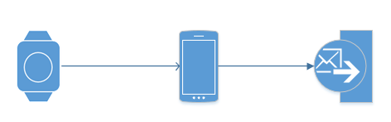

# Interpreting the results

After getting the data we display it in a graphical way using MATLAB.

## GPS

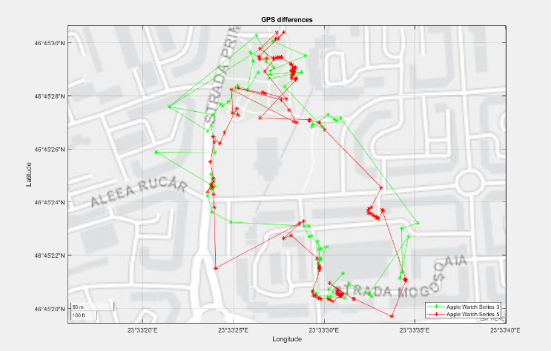

Figure x. represents a GPS test. Both watches struggle at times, but the Series 5 has more data points and less errors.

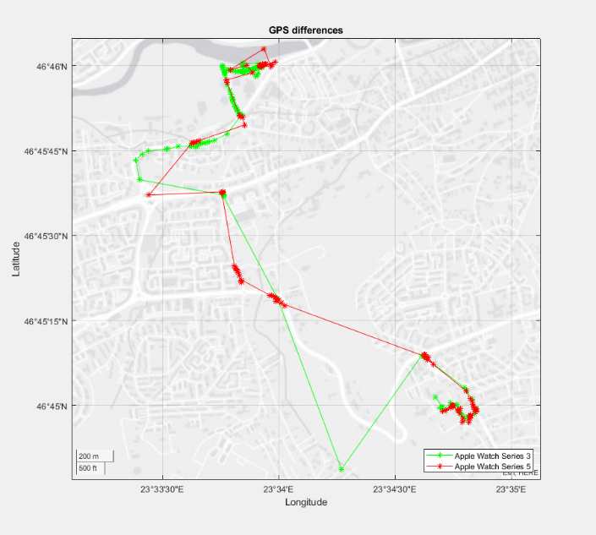

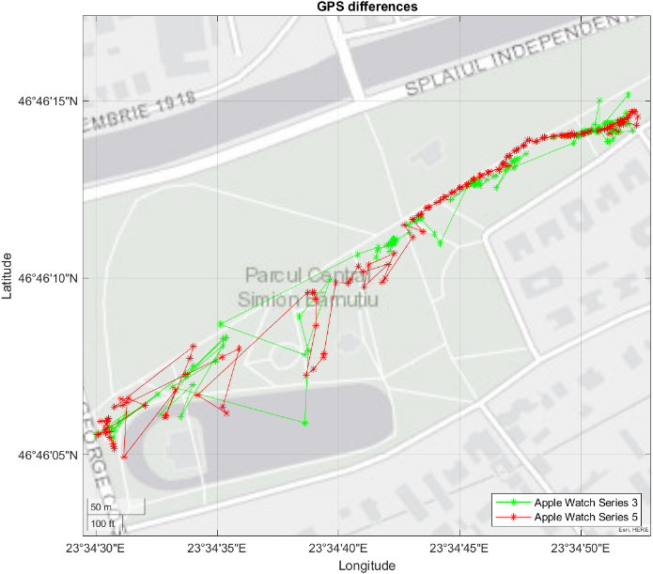

Actual route:

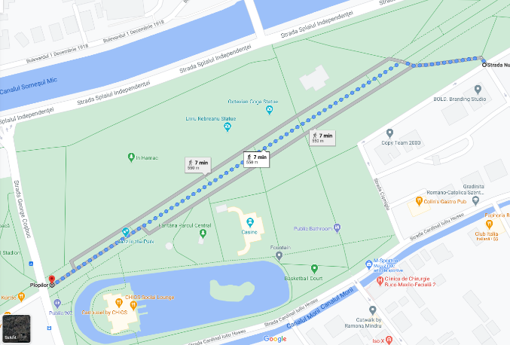

In this case, the distance (measured via Google Maps) was 550m. Series 3 measured 478m and Series 5 measured 515m. The newer one is not exact, but seems to be better at measuring distances. Also, S3 got 643 steps and S5 got 697 steps. Regarding data points, there seemed to be more data in the beginning. After that, we may assume that the watches’ battery management features decided to slow down the GPS gathering. This resulted in errors of approximately 40m (maximum) for the S3 and 25m (maximum) for the S5.

## Heart rate

During the same experiment, the following heart rate was registered:

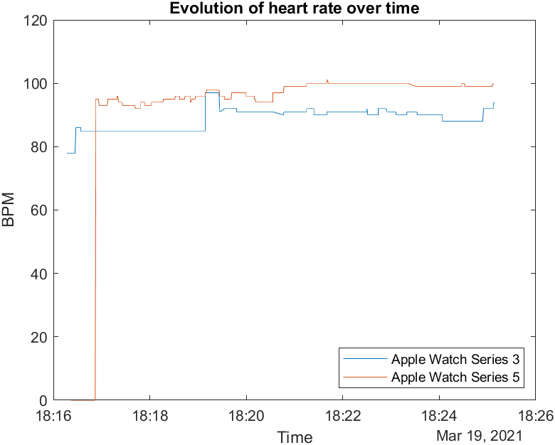

Other heart rate Data:

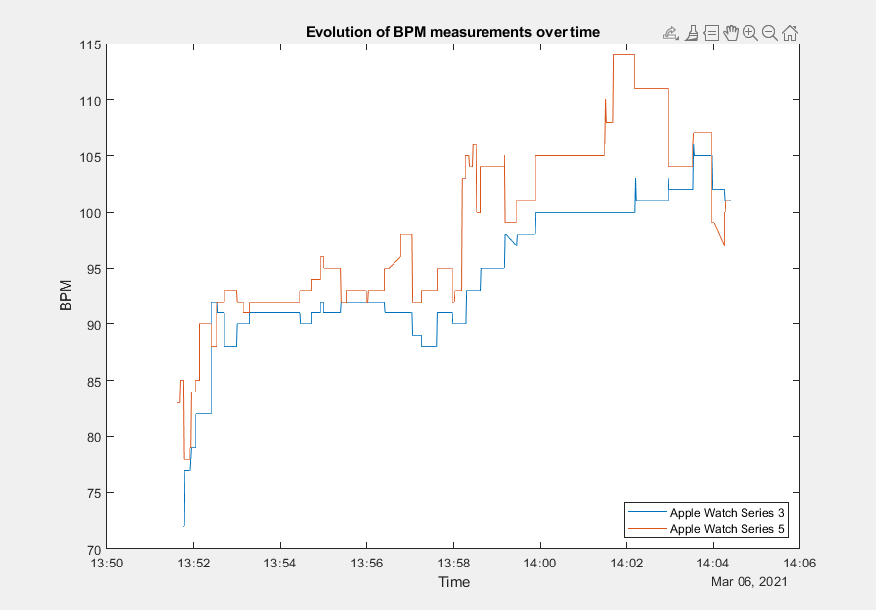

There seems to be a big difference in BPM measurements. While both watches reacted to changes in BPM in a similar way, their readings can vary. This may be due to advancements in photoplethysmogram (PPG) technology and better noise reduction while moving.

Sample 2 (while driving):

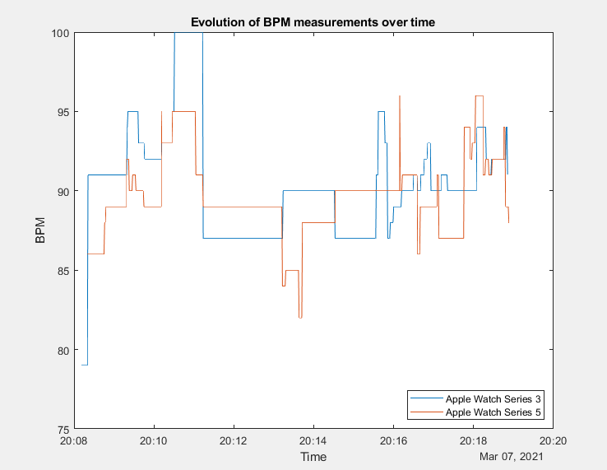

Again, we have some differences, but they are smaller than when doing more hand movement. That means that lower noise leads to a more similar PPG result for both watches.

## Steps and distance

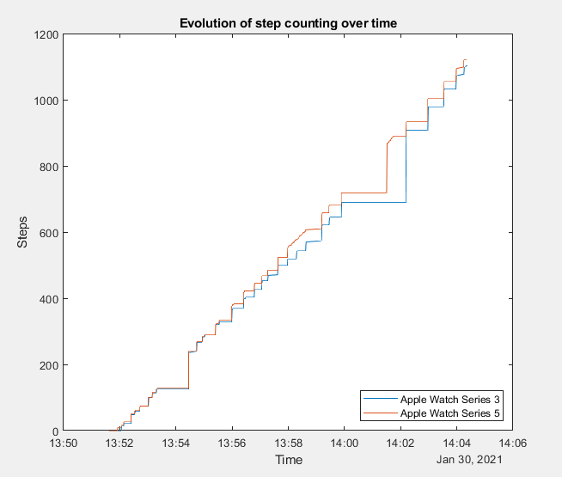

Distance and steps don’t have significant differences. Few more readings have also shown the same thing.

|  |  |  |
| --- | --- | --- |
| Sample 1 (17 minutes)  Parcul Central, Cluj-Napoca | S3 | S5 |
| Total steps | 1502 | 1515 |
| Total distance [m] | 1132.67 | 1155.22 |
|  |  |  |

|  |  |  |
| --- | --- | --- |
| Sample 2 (9 minutes)  Parcul Central, Cluj-Napoca | S3 | S5 |
| Total steps | 651 | 651 |
| Total distance [m] | 431.16 | 442.70 |

|  |  |  |
| --- | --- | --- |
| Sample 3 (13 minutes)  Old Town, Cluj-Napoca | S3 | S5 |
| Total steps | 995 | 985 |
| Total distance [m] | 694.02 | 697.51 |

|  |  |  |
| --- | --- | --- |
| Sample 4 (16 minutes)  Open field, Bălcești, Beliș, Cluj | S3 | S5 |
| Total steps | 866 | 831 |
| Total distance [m] | 591.61 | 552.62 |

|  |  |  |
| --- | --- | --- |
| Sample 5  (400m running track) | S3 | S5 |
| Total steps | 483 | 486 |
| Total distance [m] | 386.34 | 387.71 |

|  |  |  |
| --- | --- | --- |
| Sample 6  (300m running track) | S3 | S5 |
| Total steps | 343 | 346 |
| Total distance [m] | 276.32 | 279.03 |

We can see that, while differences do exist, they may usually be insignificant.

For the distance comparisons with the actual measurements, both keep a similar error, even though the Series 5 seems to be slightly better.

##### Acknowledgment *(Heading 5)*

The preferred spelling of the word “acknowledgment” in America is without an “e” after the “g”. Avoid the stilted expression “one of us (R. B. G.) thanks ...”. Instead, try “R. B. G. thanks...”. Put sponsor acknowledgments in the unnumbered footnote on the first page.

##### References

The template will number citations consecutively within brackets [1]. The sentence punctuation follows the bracket [2]. Refer simply to the reference number, as in [3]—do not use “Ref. [3]” or “reference [3]” except at the beginning of a sentence: “Reference [3] was the first ...”

Number footnotes separately in superscripts. Place the actual footnote at the bottom of the column in which it was cited. Do not put footnotes in the abstract or reference list. Use letters for table footnotes.

Unless there are six authors or more give all authors’ names; do not use “et al.”. Papers that have not been published, even if they have been submitted for publication, should be cited as “unpublished” [4]. Papers that have been accepted for publication should be cited as “in press” [5]. Capitalize only the first word in a paper title, except for proper nouns and element symbols.

For papers published in translation journals, please give the English citation first, followed by the original foreign-language citation [6].

1. N. Kalid, A. Zaidan, B. Zaidan, O. H. Salman, M. Hashim and H. Muzammil, "Based Real Time Remote Health Monitoring Systems: A Review on Patients Prioritization and Related "Big Data" Using Body Sensors information and Communication Technology," Journal of Medical Systems, vol. 42, no. 30, 2018.
2. M. U. Ahmed, M. Björkman, A. Čaušević, H. Fotouhi and M. Lindén, "An Overview on the Internet of Things for Health Monitoring Systems," in Lecture Notes of the Institute for Computer Sciences, Social Informatics and Telecommunications Engineering, vol 169, Springer, Cham, 2016.
3. P. Kakria, N. K. Tripathi and P. Kitipawang, "A Real-Time Health Monitoring System for Remote Cardiac Patients Using Smartphone and Wearable Sensors," International Journal of Telemedicine and Applications, 2015.
4. R. Burke, C. Midgley and A. Dratch, "Active Monitoring of Persons Exposed to Patients with Confirmed COVID-19," Morbidity and Mortality Weekly Report, vol. 69, no. 9, pp. 245-246, 2020.
5. H. Liang and G. Acharya, "Novel corona virus disease (COVID‐19) in pregnancy: What clinical recommendations to follow?," Acta Obstet Gynecol Scand, vol. 99, pp. 439-442, 2020.
6. M. Billinghurst and T. Starner, "Wearable devices: new ways to manage information," Computer, vol. 32, no. 1, pp. 57-64, 1999.
7. J. Block, "How An Apple Watch Helped Save A High School Football Player’s Life," 22 September 2015. [Online]. Available: https://www.huffpost.com/entry/paul-houle-apple-watch_n_5601878de4b08820d91a4688. [Accessed 22 April 2020].
8. J. R. Nance and A. L. Mammen, "Diagnostic evaluation of rhabdomyolysis," Muscle Nerve, vol. 51, no. 6, pp. 793-810, 2015.
9. M. S. Patel, D. A. Asch and a. K. G. Volpp, "Wearable devices as facilitators, not drivers, of health behavior change.," Jama, vol. 313, no. 5, pp. 459-460, 2015.
10. D. Castaneda, A. Esparza, M. Ghamari, C. Soltanpur and H. Nazeran, "A review on wearable photoplethysmography sensors and their potential future applications in health care," International Journal of Biosensors & Bioelectronics, no. 4, pp. 195-202, 2018.
11. C. Chu, H. Chiang and J. Hung, "Dynamic heart rate monitors algorithm for reflection green light wearable device," International Conference on Intelligent Informatics and Biomedical Sciences, pp. 438-445, 2015.
12. J. Spigulis, L. Gailite, A. Lihachev and R. Erts, "Simultaneous recording of skin blood pulsations at different vascular depths by multiwavelength photoplethysmography," Applied Optics, vol. 46, no. 10, pp. 1754-1759, 2007.
13. P.-H. Lai and I. Kim, "Lightweight wrist photoplethysmography for heavy exercise: motion robust heart rate monitoring algorithm," Healthcare Technology Letters, vol. 2, no. 1, pp. 6-11, 2015.
14. Z. Ge, P. W. C. Prasad, N. Costadopoulos, A. Alsadoon, A. K. Singh and A. Elchouemi, "Evaluating the accuracy of wearable heart rate monitors," 2016 2nd International Conference on Advances in Computing, Communication, & Automation (ICACCA) (Fall), Bareilly, 2016, pp. 1-6. .
15. V. Genovese, A. Mannini and A. M. Sabatini, "A Smartwatch Step Counter for Slow and Intermittent Ambulation," IEEE Access, vol. 5, pp. 13028-13037, 2017.
16. J. A. Lee, S. M. Williams and K. R. L. Dale D. Brown, "Concurrent validation of the Actigraph gt3x+, Polar Active accelerometer, Omron HJ-720 and Yamax Digiwalker SW-701 pedometer step counts in lab-based and free-living settings," Journal of Sports Sciences, vol. 33, no. 10, pp. 991-1000, 2015.
17. T. CB, A. JJ and S. EE, "Accuracy of a step counter during treadmill and daily life walking by healthy adults and patients with cardiac disease," BMJ Open, vol. 7, no. 3, 2017.
18. Y. Bai, P. Hibbing, C. Mantis and G. J. Welk, "Comparative evaluation of heart rate-based monitors: Apple Watch vs Fitbit Charge HR," Journal of Sports Sciences, vol. 36, no. 15, pp. 1734-1741, 2018.
19. Veerabhadrappa, M. M. P. and M. Renninger, "Tracking Steps on Apple Watch at Different Walking Speeds," J GEN INTERN MED, vol. 33, pp. 795-796, 2018.
20. "Calibrating your Apple Watch for improved Workout and Activity accuracy," Apple Inc., 2019 October 2017. [Online]. Available: https://support.apple.com/en-us/HT204516. [Accessed 25 April 2020].
21. K. Kuo and F. Wu, "A 2.4-GHz/5-GHz Low Power Pulse Swallow Counter in 0.18-μm CMOS Technology," IEEE Asia Pacific Conference on Circuits and Systems, pp. 214-217, 2006.
22. B. A. Abdou, "Commercializing eSIM for Network Operators," IEEE 5th World Forum on Internet of Things (WF-IoT), pp. 616-621, 2019.
23. K. W. Nixon, X. Chen and Y. Chen, "Footfall - GPS polling scheduler for power saving on wearable devices," 21st Asia and South Pacific Design Automation Conference (ASP-DAC), pp. 563-568, 2016.
24. M. Collotta, G. Pau, T. Talty and O. K. Tonguz, "Bluetooth 5: A Concrete Step Forward toward the IoT," IEEE Communications Magazine, vol. 56, no. 7, pp. 125-131, 2018.
25. S. S. M. Nino Isakadze, "How useful is the smartwatch ECG?," Trends in Cardiovascular Medicine, 2019.
26. "Apple Watch Series 5 - Health," Apple Inc., [Online]. Available: https://www.apple.com/apple-watch-series-5/health/. [Accessed 01 06 2020].
27. "Taking an ECG with the ECG app on Apple Watch Series 4 or later," Apple Inc., [Online]. Available: https://support.apple.com/en-us/HT208955. [Accessed 01 06 2020].

**IEEE conference templates contain guidance text for composing and formatting conference papers. Please ensure that all template text is removed from your conference paper prior to submission to the conference. Failure to remove template text from your paper may result in your paper not being published.**